**ASS-4**

1) Write a shell script to print

* your are logged in as which user
* in which directory you are
* and in which terminal you are working
* total number of files and directories in current directory

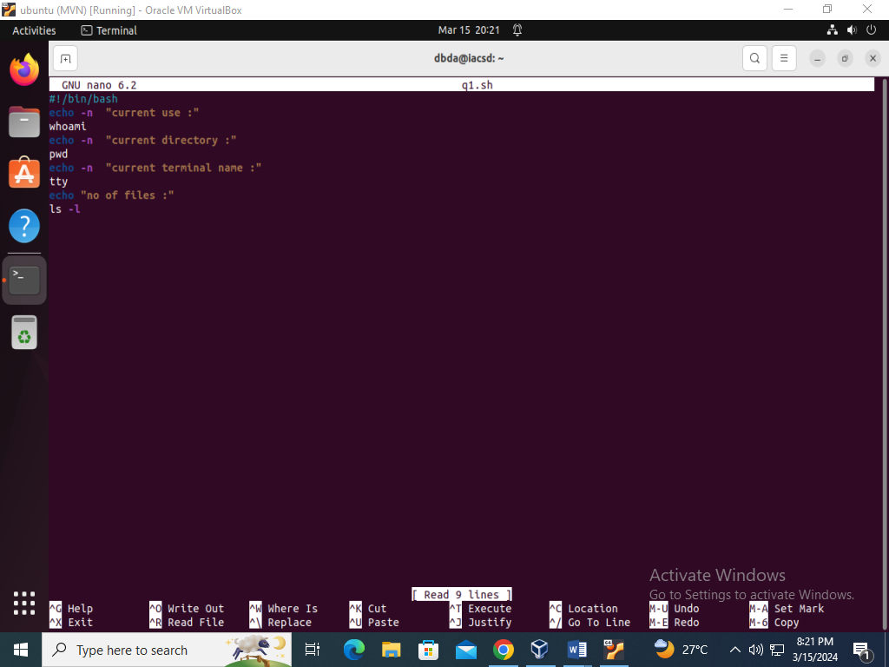

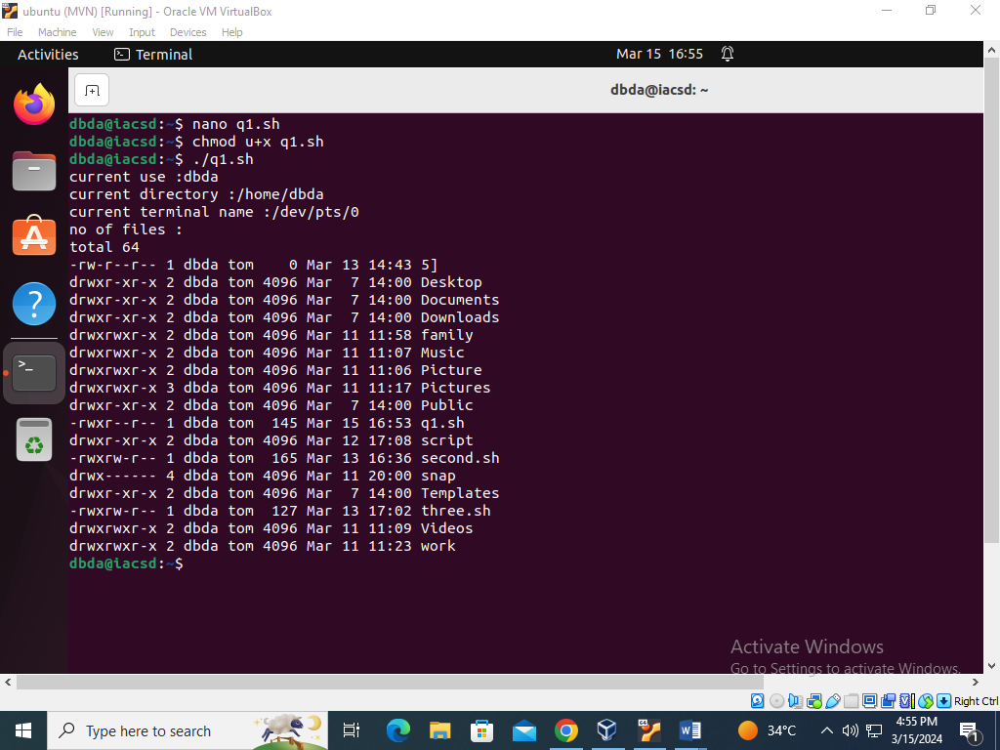

2).Write a shell script to create a menu driven program for adding, deletion or finding a record in a database. Database should have the field like rollno, name, semester and marks of three subjects. Last option of the menu should be to exit the menu.

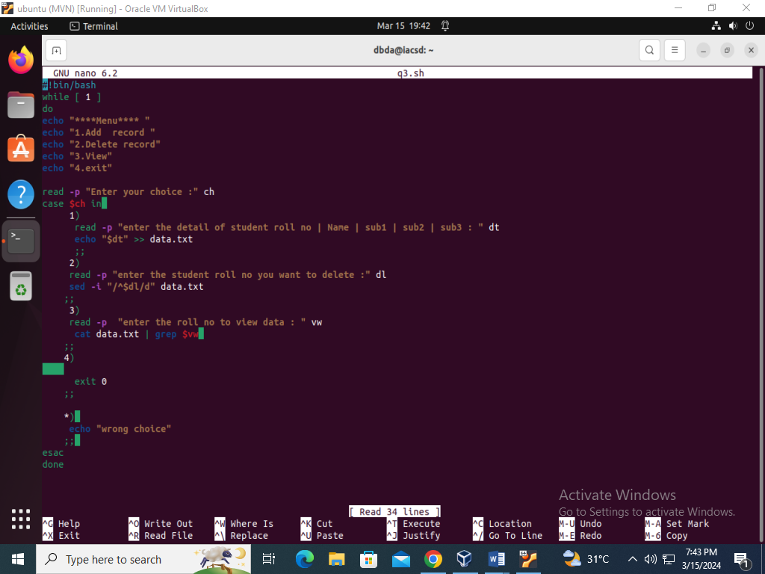

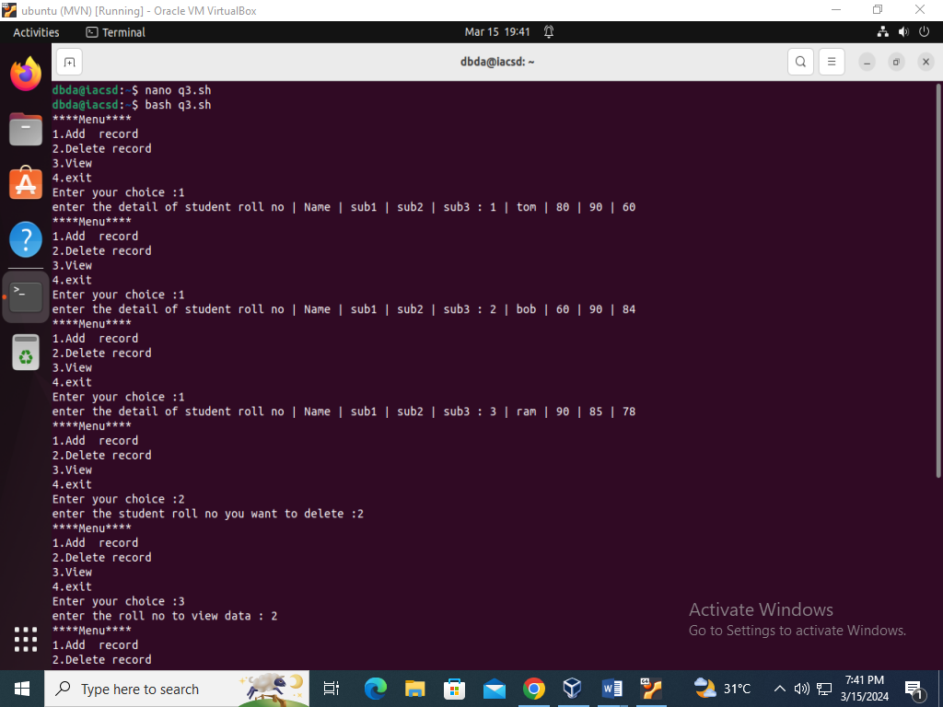

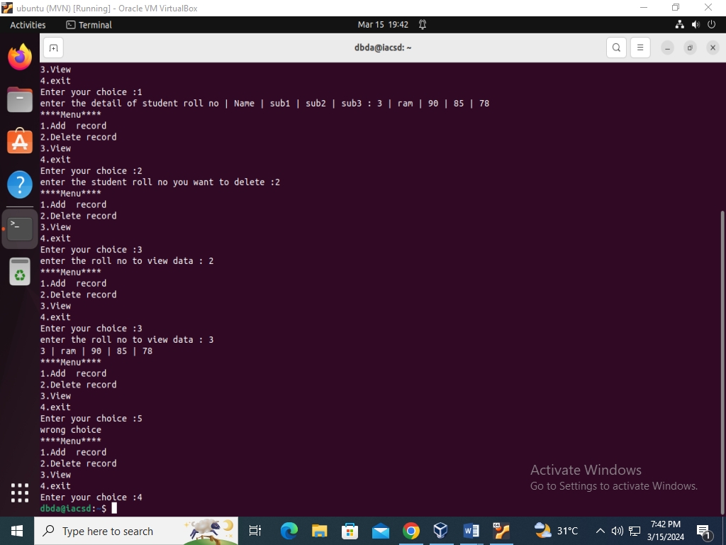

3) Write a Linux shell script to accept 10 number and tell how many are +tive, -

tive and zero.

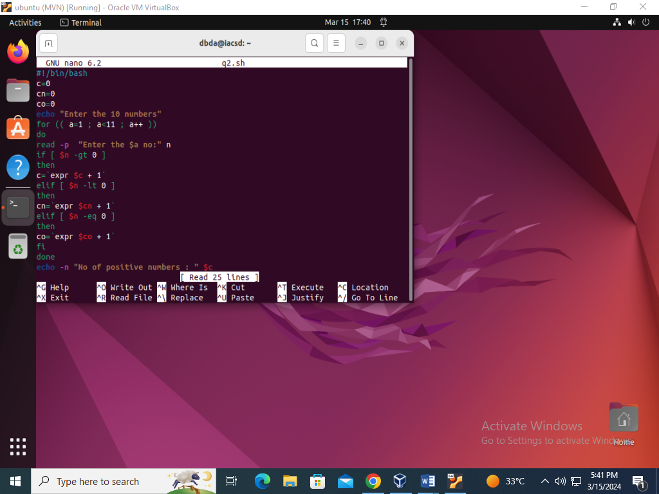

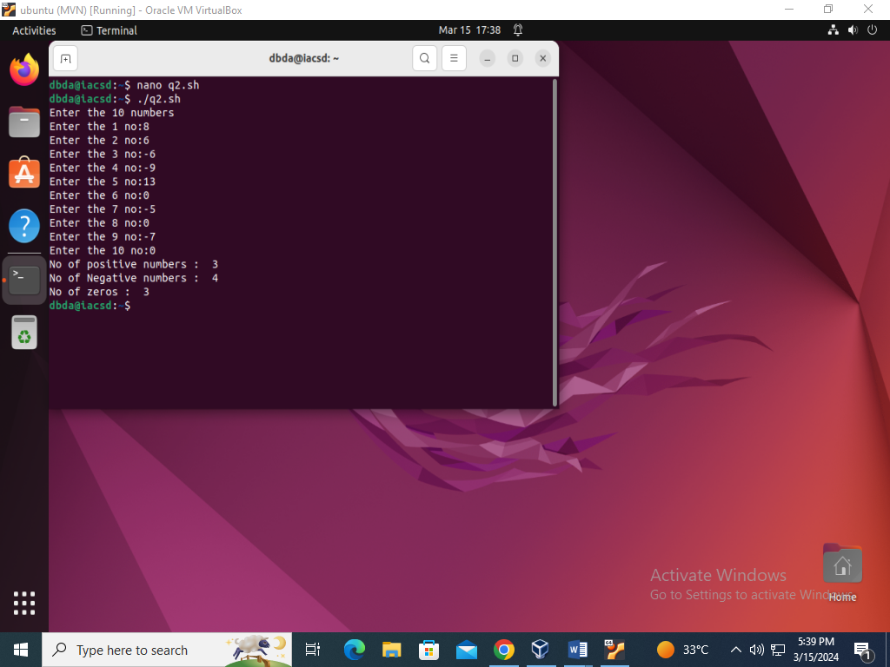

4) Write a shell script to accept five number and display max and min value.

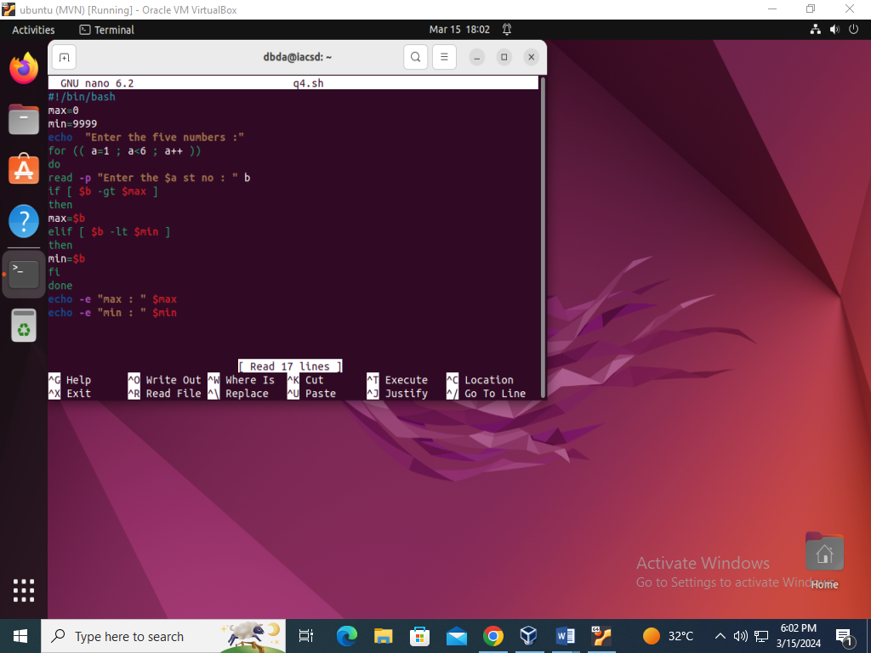

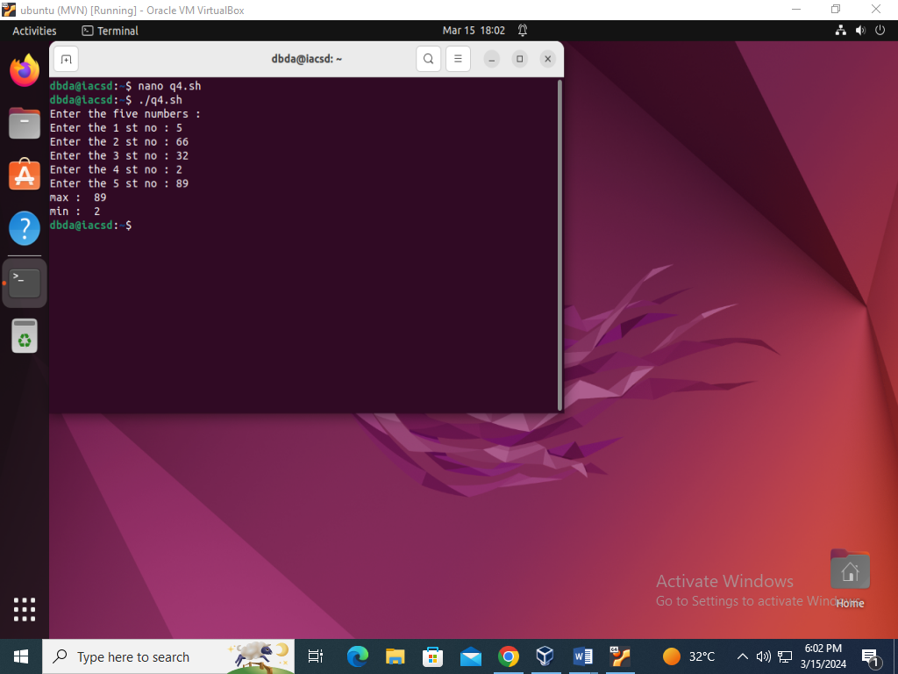

5) Write a script to find out String is palindrome or not.

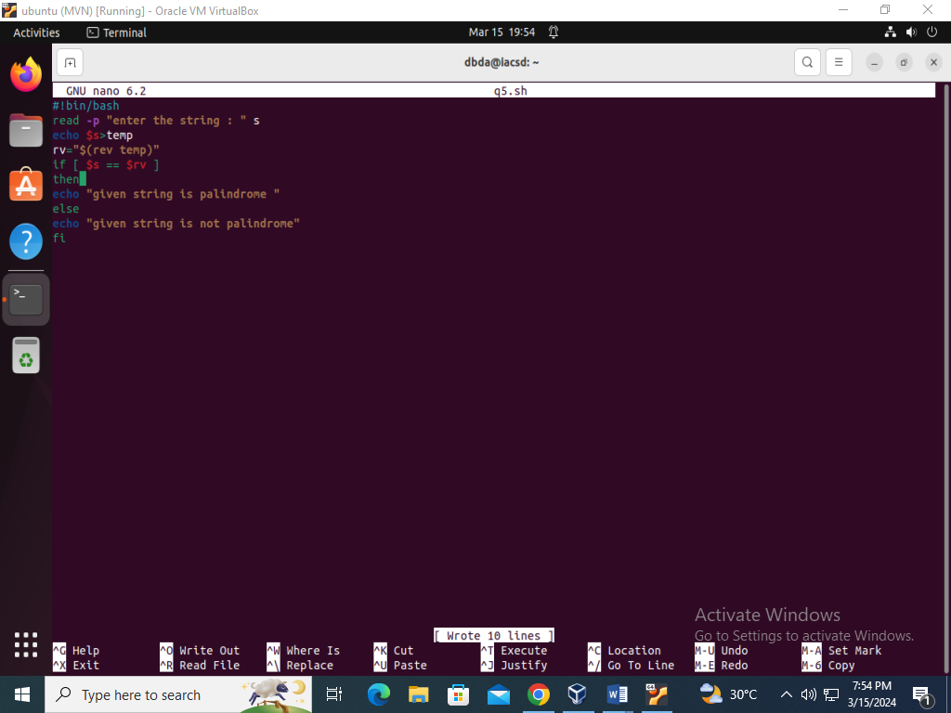

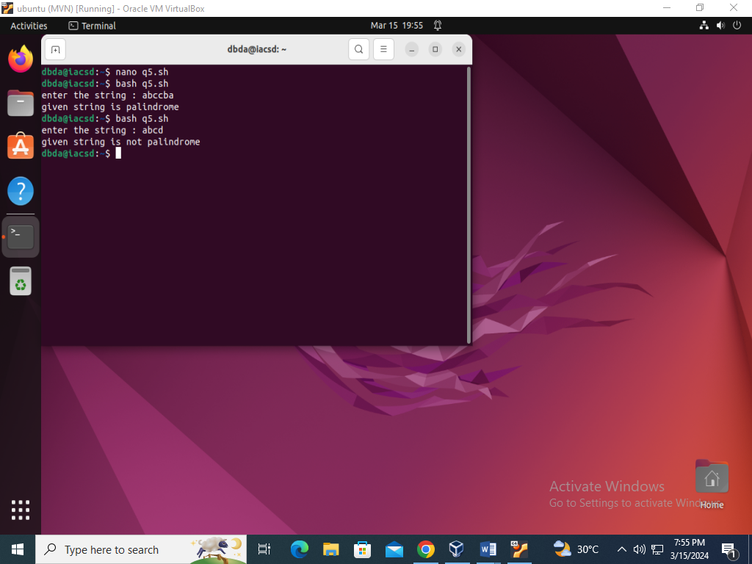

6) Write a shell script to print given number’s sum of all digits (eg. If number is 123, then it’s sum of all digits will be 1+2+3=6)

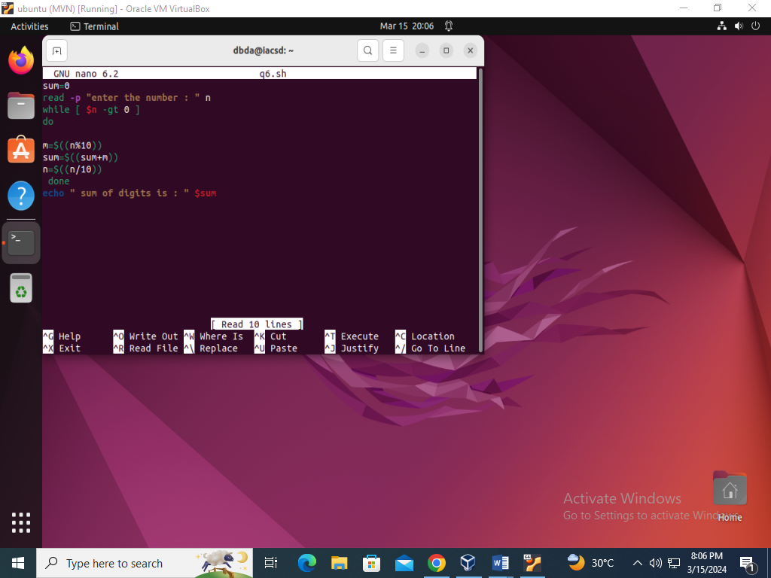

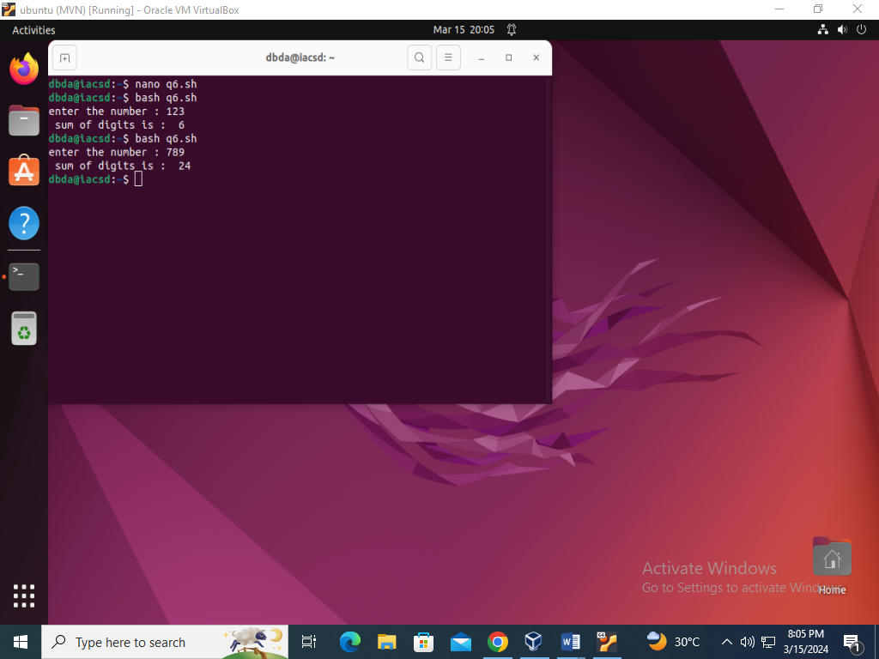

7) Create a script to

Create user , Delete user , Create group , delete Group using case

